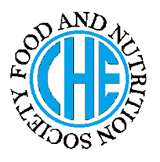 | DIETARY MANAGEMENT OF  DISEASE
Made by Farah Syed on 28-4-12 as a part of course no Of BS HE
under the guidance of Prof. Dr. Rubina Hakeem (RH)

DESCRIPTION OF THE DISEASE/ DISORDER
- What is acute renal failure?
Acute renal failure (ARF) is the rapid, often reversible, deterioration of renal function frequently characterized by fluid and electrolyte imbalances and muscle wasting.
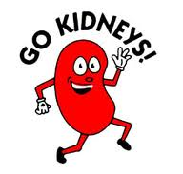

CAUSES OF THE DISEASE/ DISORDER
- What causes acute renal failure?
- Traumatic injury such as severe burns and following surgery on the abdomen.
- Infectious diseases
- Toxic agents like carbon tetra chloride, poisonous mushrooms, and certain drugs like penicillin.

NUTRITIONAL CONSIDERATIONS
- PROTEINS: Adjust protein needs as renal function, dialysis therapy, or stress levels changes.

- FATS: not relevant
- CARBOHYDRATES: Carbohydrate intake should be increased to provide calories for the energy demands of the illness.

- FIBER: not relevant
- VITAMINS: Vitamin C should be provided to support the needed energy metabolism and tissue healing.
- Supplementation of water-soluble vitamins is often indicated due to losses from dialysis.

- MINERALS: Requirement s depends on lab value, type of dialysis and use of diuretics.
- FLUID REQUIREMENTS: Fluid intake should balance with the output.

- ENERGY REQUIREMENTS: Energy needs increase with accompanying stress.

DIETARY CONSIDERATIONS
Healthy kidneys get rid of protein waste products, extra minerals, and fluid that your body does not need. Because your kidneys are not working well, you need to follow a special meal plan.

COOKING TIPS:
- Don’t add too much salt and other salt seasoning when cooking.
- Add lemon juice, vinegar, herbs and spices that do not contain salt to add flavor.
- Use standard measuring cups and spoons to measure portions of food and ingredients.
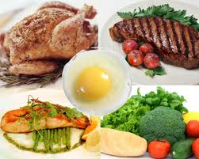
Do’s | Moderation | Don’ts
Read label before buying any food item such as if salt or sodium is listed as one of the first five ingredients the food is high in sodium and should not be bought.  Buy meat, fruits and vegetables that are fresh. | Not relevant | Don’t eat canned vegetables that have added salt.  Avoid instant hot cereal.
FOOD AND DRUG/ DISEASE INTERACTIONS ORTREATMENT SIDE EFFECTS
Does this effects nutrient absorption or requirement?
Do the medicines used in disease interact with food or nutrients and require special considerations?
Do the treatments other than medicines have any side effects?
NOT RELEVANT

References used:
- MANUAL OF AMERICAN DIETETIC ASSOCIATION
- NUTRITION CARE MANUAL

Sources of further information:
e.g. websites, organizations etc 