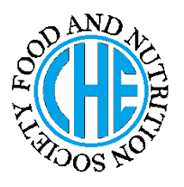 | DIETARY MANAGEMENT OF  DIETARY MANAGEMENT OF  CARDIAC SURGERY  CARDIAC DISEASE
Made by SAMRA DOSSAL on 26th April 2012 as a part of
Made by SAMRA DOSSAL on 26th April 2012 as a part of
BS HE

under the guidance of Prof. Dr. Rubina Hakeem (RH)

Of BS HE
under the guidance of Prof. Dr. Rubina Hakeem (RH)

WHAT IS CARDIAC SURGERY

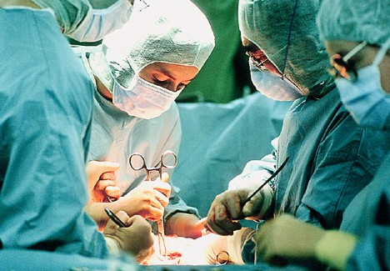

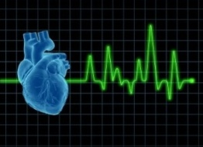

- Cardiovascular surgery is a surgery on the heart vessels performed by cardiac surgeons.

- In cardiac surgery patients undergo coronary artery bypass graft atherectomy.

CAUSES OF CORONARY HEART DISEASE

Causes of Cardiac Surgery are:
- Obesity
- Diabetes
- Hypertension
- Hyperlipidemia

NUTRITIONAL CONSIDERATIONS

- PROTEINS
Protein requirement are normally 0.8-1.0 g protein per kg body weight.

- FATS
Limit saturated fats and trans fats example:
- Saturated Fats: meat, poultry skin, bacon, sausage, whole milk, cream, and butter.
- Trans Fats: margarine, shortenings and some fried foods

- CARBOHYDRATES: N.R

- FIBER
Get 20 g to 30 g of dietary fiber per day.

- VITAMINS : N.R

- MINERALS: N.R

- FLUID REQUIREMENTS: N.R

- ENERGY REQUIREMENTS
Patients with severe heart failure may require a 20% to 30% increase in calories.

DIETARY CONSIDERATION

The nutrition needs of the patient undergoing cardiac surgery and/or interventional cardiology depend upon the individual’s preoperative nutrition status, other co-morbid conditions such as diabetes, the type of surgery, and postoperative or post procedure complications

POST OPERATIVE NUTRITION CARE

Immediately following the surgery, the focus of care is on the recovery and healing.
- Healthy professionals should work closely with patients who are unable to resume normal diet after surgery.
- Step 1 diet is most commonly prescribed that is low in cholesterol, fats, and saturated fatty acids.
- Some foods/meals not normally recommended in step 1 diet are allowed to promote healing during 4 to 6 weeks.
- Fluid restrictions may be required for patients with renal failure or edema.

Recommended Foods |  |  | Foods Not Recommended
Grains | Whole grain breads and cereals, including oats and barley, Pasta. |  | Grains | High-fat bakery products, such as doughnuts, biscuits.  Snacks, cheese puffs etc.
Vegetables | Fresh, frozen, or canned vegetables without added fat or salt. |  | Vegetables | Fried vegetables, Vegetables prepared with butter, cheese, or cream sauce.
Fruits | Fresh, frozen, canned, or dried fruit. |  | Fruits | Fried fruits, Fruits served with butter or cream.
Meat and Other  Protein Foods | Lean cuts of beef, Skinless poultry, Fish, Dried beans and peas, Nuts, Egg whites or egg substitute. |  | Milk | Whole milk, 2% fat milk  Whole milk yogurt .
 |  |  | Protein Foods | Fried meat, Whole eggs and egg yolks, Poultry with skin.
Fats and Oils | Unsaturated oils (olive, peanut, Salad dressings  Seeds and nuts. |  | Fats and Oils | Butter, Stick margarine, Shortening, Partially hydrogenated oils.
DRUG NUTRIENT INTERACTION

Drugs commonly prescribed and effect the nutritional status and dietary modification for patients undergoing cardiac surgery.
- Digitalis Intoxication – May result in hypokalemia which may cause anorexia, abdominal pain.
- Quinidine – Can decrease gastrointestinal tolerance and may cause nausea, diarrhea.
- Thiazide Diuretics – Can contribute to hypercholesterolemia which negate positive effect of a low-saturated-fat diet.
- Amiodarone – Causes nausea, constipation, increase or decrease appetite.

References used:
Nutrition Care Manual
American Dietetics Association
References Used

