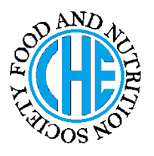 | DIETARY MANAGEMENT OF  HIGH BLOOD CHOLESTEROL
Made by KIRANSHIWANI on 26-04-2012as a part ofcourse no Of BSHE
under the guidance of Prof. Dr. Rubina Hakeem (RH)

DESCRIPTION OF HIGH BLOOD CHOLESTEROL
Classification Of Cholesterol

Cholesterol
is a major component of brain and nerve tissue, it is found in many food mainly in animal food, and also synthesized by the body. [1]

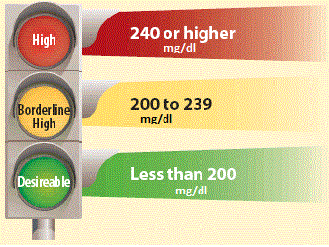
Assessment
Serum total cholesterol should be measured in
- Adults of 20 years of age.
- Older atleast every 5 year.[3]
High Blood Cholesterol
is a condition characterized by very high level of cholesterol in the blood. By this condition, the incidence of plaque in the arteries &its complication increase.[2]

[10]
CAUSES OF HIGH BLOOD CHOLESTEROL
- Obesity  - Smoking  - High Consumption Of Coffee  - Diabetes | - Hypertension  - High sugar diet  - Physically inactive.[4]
NUTRITIONAL CONSIDERATIONS
- Carbohydrates are taken approximately 55% of total calories.[5]
- Protein should be taken approximately 15% of total calories.[5]
- Keep the total amount of fat that you eat (including heart-healthy fats) to 25% to 35% of total calories [6]
- Limit the amount of cholesterol that you eat to less than 200 milligrams (mg) perday.[5]
- Get 20 g to 30 g of dietary fiber per day: Fruits, vegetables, whole grains, dried beans are good sources of fiber.[6]

DIETARY CONSIDERATIONS

- VLFHC(Very Low Fat High Carbohydrate)diet should be taken.  - E.G whole grains and vegetables.[7]  - Mediterranean diet( plant based diet) focus on fruits, cereal, fish, poultry. Egg consume in moderation.[7]  - Fruits, vegetables, whole grains and dried beans are good sources of fiber.[8]  Do’s Don’ts |  | - Take antioxidant in your diet.  - E.G (citrus fruit like grape fruit, orange.[7]  - Eat more omega-3  - Aim to eat fish twice a week.  - Other foods with omega3 fat include walnuts, canola and soybean oils.[8]
Meat group (5-6 oz/day  Beef(lean cuts well trimmed before cooking) ,poultry without skin, fish, egg white  .Milk group (2-3cups/day)  Non fat Milk (fluid , powdered), yogurt (non fat or low fat), cheese (low fat natural) . low fat or non fat ice cream, low fat coffee.  Bread, cereal, ,rice &pasta  (6 or more serving/day)  Brown bread, oat, wheat, corn, pasta, rice, crackers (low fat), bran muffin, pancake (using un saturated oil).  Vegetable group (3-5 serving/day)  Fresh, frozen , and canned vegetables.  Fruit group (2-4 servings/day)  Fresh, frozen , and canned fruits.  Fats and oil(<6-8 tsp/day)  Unsaturated oil (Sunflower oil ,soybean, corn, cotton seed, canola, olive,), margarine made from unsaturated oil, salad dressing(made with unsaturated fat)peanut butter., cocoa powder. |  | Meat group (5-6 oz/day)  Beef, pork, spare ribs, poultry with skin, fried fish and chicken, egg, salami, sausages.  Milk group (2-3cups/day)  Whole milk, whole milk yogurt, cheddar, whole milk Mozzarella ,cream cheese, regular ice cream, cottage cheese.  Bread, cereal, ,rice&pasta.  (6 or more serving/day)  Bread made with fat, Egg & butter, commercially baked products , pastries and biscuits.  Vegetable group (3-5 serving/day)  Vegetables fried or prepared with butter, cheese or cream sauce.  Fruit group(2-4 servings/day)  fruits fried or fruits served with butter, cheese or cream sauce, avocados, olive.  Fats and oil(<6-8 tsp/day)  Coconut and palm oil, butter, dressing made with egg yolk, coconut, chocolate milk. [9]
REFERENCES

1)Food, Nutrition And Diet Therapy BY Krause’s
2) American Dietetic Association
3) Nutrition Care Manual

