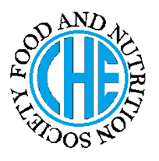 | DIETARY MANAGEMENT OF  CELIAC DISEASE
Made by Sidra iqbal on 26-04-2012 as a part of course no ----Of BS HE
under the guidance of Prof. Dr. Rubina Hakeem (RH)

DESCRIPTION OF THE DISEASE/ DISORDER

Celiac disease (CD), is an autoimmune genetic disorder involving the small intestine. It is characterized by atrophy of the villi, crypt hypertrophy, and damage to the microvilli in the duodenum and jejunum in response to the ingestion of gluten.
The disease is accompanied by a marked reduction in absorptive surface area of the small intestine and a decreased uptake and transport of nutrients. Although celiac disease was formerly regarded primarily as a childhood disease, it is now recognized that the symptoms often develop in adults, who often present with a typical rather than classic symptoms. Women are diagnosed more frequently than men, and the number of individuals being diagnosed, especially between 30 to 60 years of age, is increasing
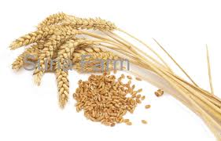
CAUSES OF THE DISEASE/ DISORDER

Celiac disease is caused by the ingestion of gluten and gluten containing products by gluten sensitive peoples.
Gluten is a general name given to storage proteins (prolamins) present in wheat, rye, barley and oats. The specific names of the cereals prolamins that are toxic in celiac disease are gliadin in wheat, secalin in rye, hordein in barley and avenin in oats.
NUTRITIONAL CONSIDERATIONS

- Any product entering the digestive system must be gluten free.
- Always check list of ingredients before purchasing any food product because many additives, stabilizers and preservatives may contain gluten. In addition, some medications, tooth pastes and mouthwashes may contain gluten.
- If initial symptoms are very severe such as nausea, diarrhea, avoidance of lactose containing foods in addition to a gluten free diet may be beneficial.
- In severe cases, malabsorption of fats, calcium, magnesium, fat soluble vitamins A,D,E,K, iron and vitamin B12 can occur therefore, supplemental vitamins and minerals may required.

DIETARY CONSIDERATIONS

- Diet for celiac patients should not contain wheat, rye, barley and oats.
- Bread and baked products made from wheat flour should not be allowed, only those bread and baked products made from corn, soya, arrowroot, pea flour, cornstarch, potato flour can be taken.
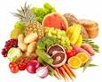
- Cereals, pasta made from wheat rye barley oats should not allowed. But made from ingredient other than this can be taken.
- Ice creams, cake, cookies, muffins, pies, pastries made with wheat, rye, barley should not be allowed.
- Milk yogurt, cheese. Fresh, frozen and canned meat, vegetables, fruits, meat are all allowed.
- Lentils, chickpeas, peas, beans, nuts, seeds are also allowed.
- Fats, butter, cream are also allowed.
- Similarly, tea, coffee, honey are allowed.
Do’s | Moderation | Don’ts
Rice  Corn  beans  lentils  vegetables  fruits  meat  milk  eggs  yogurt  cheese  cream | NR | Wheat  Rye  Barley  Oats  Cake  Pizza dough  Biscuits  Bread
FOOD AND DRUG/ DISEASE INTERACTIONS ORTREATMENT SIDE EFFECTS

NR

References used:

American Dietetic Association Manual of Clinical Dietetics 6th edition.
Sources of further information:
e.g. websites, organizations etc
NR

